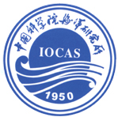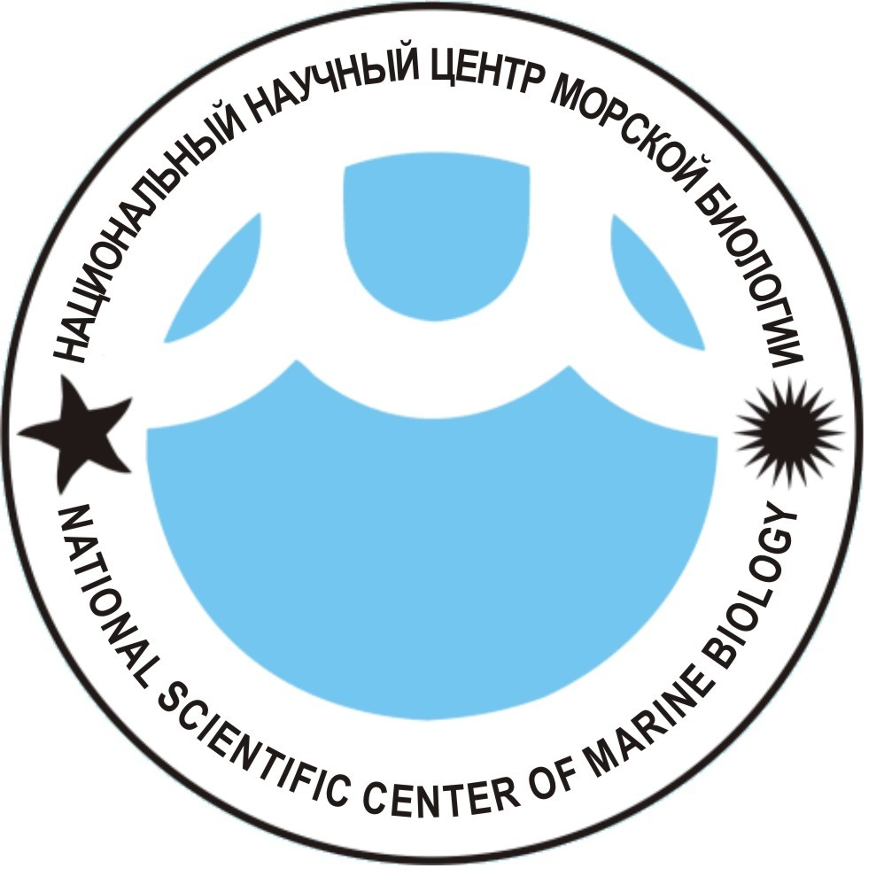

Institute of Oceanology, Chinese Academy of Sciences (IOCAS)
National Scientific Center of Marine Biology FEB RAS
Asia-Pacific Network for Global Change Research (APN)

International Conference on

“Life-supporting Asia-Pacific Marine Ecosystems, Biodiversity and their Functioning”

In the April 26-29, 2017, Institute of Oceanology CAS and National Scientific Center of Marine Biology FEB RAS with support of the APN (Asia-Pacific Network for Global Change Research) will hold a conference with main theme “Life-supporting Asia-Pacific Marine Ecosystems, Biodiversity and their Functioning”.
Sessions Topics:
Climate/global environmental changes and possible effects on the marine biodiversity in East Asia.
Physical forcing to marine biodiversity: sea water chemistry, water motion and currents, etc.
Marine biodiversity and marine ecosystems management (including estuarine).
Physiology and reproduction of the marine organisms.
Conservation, management and sustainable exploitation of the marine living resources.

Oral presentations and Poster Session are planned!

Please send the Registration information (see registration form) to Dr Xiaoxia Sun (xsun@qdio.ac.cn) and Dr Tatiana N. Dautova (tndaut@mail.ru ).

Participants are invited to submit extended abstracts to be published as Proceedings of the Conference; deadline is February 25, 2017.
Extended abstracts must not exceed 4 pages, Microsoft Word, body text in Times New Roman font with 12pt size, may include 1-2 figures in *jpg or *tiff format (not more than 400 kb each, they should not inserted into the text and sent as separate files) and a very short list of references (up to 5-6); author(s) and affiliations should follow on line below title. References should be presented as follows, in alphabetical order (do not abbreviate journal names):

books: Habe T. 1977. Systematics of Mollusca in Japan. Bivalvia and Scaphopoda. Tokyo: Hokuryukan. 372 p.
journal papers: Fujii S. 1987. The molluscan fauna from Toyama Bay in the Japan Sea // Journal of the College of Liberal Arts, Toyama University (Natural Science). V. 20, N 1. P. 17–31.
book chapters: Lü D. 2004. Family Acmaeidae // Seashells of China. Qi Zhongyan (Ed.). Beijing: China Ocean Press. P. 14–15.

All abstracts must be submitted electronically as an e-mail attachment to Dr Tatiana Dautova using tndaut@mail.ru.
Venue of the conference – Institute of Oceanology CAS, Qingdao, China.

ORGANIZING COMMITTEE

Prof. Sun Song, Director of the Institute of Oceanology CAS (co-chair);
Prof. Andrey Adrianov, Director of National Scientific Center of Marine Biology FEB RAS, Russia (co-chair);
Prof. Xiaoxia Sun, Institute of Oceanology, CAS (co-chair);
Prof. Tatiana N. Dautova, National Scientific Center of Marine Biology FEB RAS and FEFU, Russia (co-chair);
Dr. Konstantin A. Lutaenko, National Scientific Center of Marine Biology FEB RAS, Russia (co-chair);
Prof. Li Chaolun, Institute of Oceanology, CAS;
Prof. Xu Kuidong, Institute of Oceanology, CAS;
Prof. Yu Rencheng, Institute of Oceanology, CAS;
Dr. Elena E. Kostina, National Scientific Center of Marine Biology FEB RAS Mrs Marina Gorelaya, National Scientific Center of Marine Biology FEB RAS

We look forward to seeing you in Qingdao in 2017

